VISITING PROFESSORS OF THE FIRST FACULTY OF MEDICINE,
CHARLES UNIVERSITY

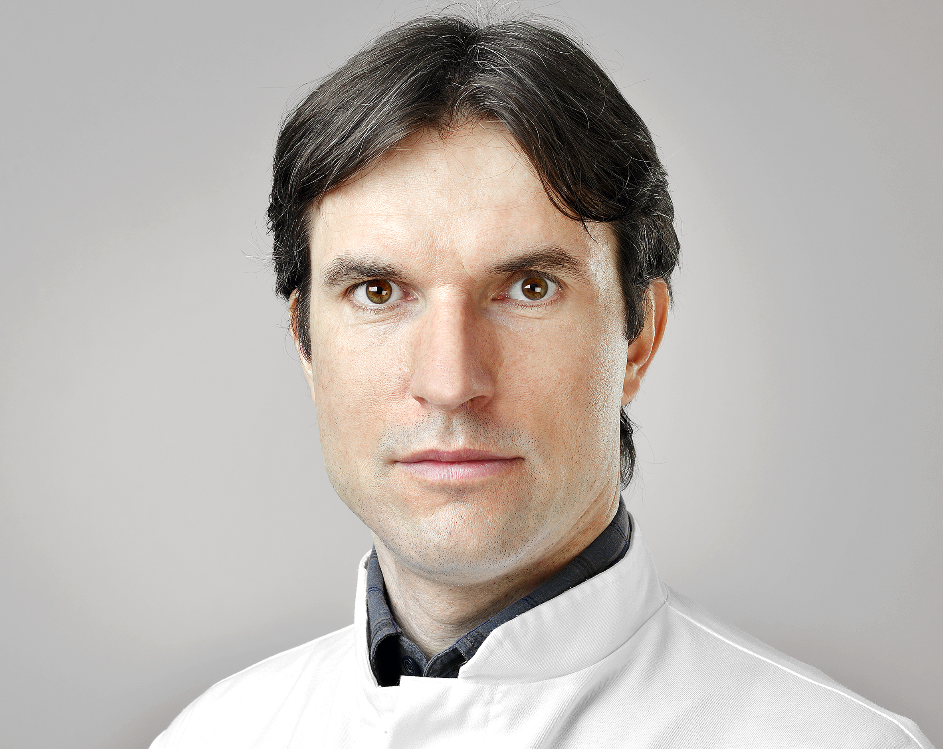
Visiting Professor
Prof. Stefan Rammelt, Dr. med., PhD

Visiting Professor Home Institution
Foot & Ankle Section, University Centre of Orthopaedics and Traumatology, University Hospital Carl Gustav Carus, Dresden
Unit of the 1st Faculty of Medicine
Department of Orthopedics, First Faculty of Medicine, Charles University and Military University Hospital, Prague

Institute of Anatomy, First Faculty of Medicine, Charles University

Fields of Activity foot and ankle traumatology
Long-time collaborator with the Department of Orthopedics, First Faculty of Medicine, Charles University, the Military University Hospital, Prague and the Institute of Anatomy.
He participates in the lecture symposium Czech-Saxon Days (since 2010) aimed at promoting foot and ankle traumatology in the Czech Republic. Participates in clinical-anatomical symposiums held at the Institute of Anatomy of our Faculty.
Publications & Output
will be added

