VISITING PROFESSORS OF THE FIRST FACULTY OF MEDICINE,
CHARLES UNIVERSITY
Visiting Professor
Prof. Markus Wolfgang Büchler, Dr. Med.

Visiting Professor Home Institution
Department of Surgery, Heidelberg University
Unit of the 1st Faculty of Medicine
First Department of Surgery – Department of Abdominal, Thoracic Surgery and Traumatology,

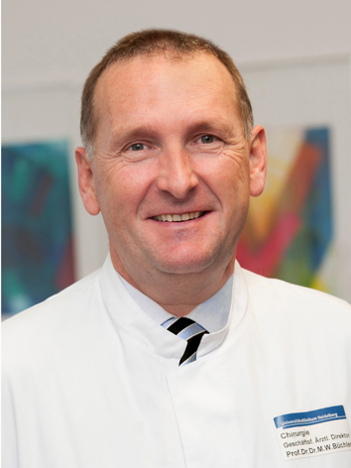
Fields of Activity
Abdominal surgery – liver transplantation, surgery of the bile ducts and the pancreas.

Research in the area of abdominal surgery, primarily focusing on liver transplantation and surgery of the bile ducts and pancreas. Collaborates with the 1st Department of Surgery in the form of consultations and partnering with staff on scientific research and clinical practice.

Publications & Output
Recommended procedures for the identification, classification, and treatment of pancreatic diseases – guidelines that have been adopted by the Czech Surgical Society of the J.E. Purkinje Czech Medical Association (ČCHS JEP) and European-African Hepato-Pancreato-Biliary Association (EHPBA).
Krška Z, Hoskovec D, Büchler M, Ulrych J, Hořejš J, Krechler T, Škrha J. Surgery of pancreatic cancer. Pancreatic Cancer News, 2017, 4: in press.

